**S222 PRT582 SOFTWARE ENGINEERING: PROCESS AND TOOLS**

**Assignment-1**

**Rock-Paper-Scissor Game in python using Test Driven Development**

**Name: Pavan Kumar Menugonda**

**ID: 354190**

**Table of contents**

**INTRODUCTION**

**OBJECTIVE**

**REQUIREMENTS**

**TOOLS**

**PROCESS:**

**TEST 1**

**TEST 2**

**TEST 3**

**CONCLUSION**

**INTRODUCTION:**

Rock-paper-scissor game is a classical game, here the objective is to play between the computer that takes user input and plays five rounds and decides the winner.

The requirements of the game are Rock > scissor, paper > scissor, paper > rock, one point for every time winning until five rounds, player can quit the game any time.

The test cases are performed by python framework called unit-test. It is a method of testing small pieces of code. By doing this we can verify small bunch of code.

Test driven development process is performed for this project using unit-test.

**OBJECTIVE**

Using Test Driven Development, Rock-Scissors-Paper game is built in python

by evaluating all the requirements.

**REQUIREMENTS**

1. Computer randomly picks one of Rock, paper, or scissors.
2. Player can choose the option.
3. One point is given to the winner.
4. Five rounds will be played.
5. At the fifth round points were displayed.
6. Player can also quit the game any time of the game.
7. rock vs paper 🡪 paper wins
8. rock vs scissor 🡪 rock wins
9. paper vs scissor 🡪scissors wins

**TOOLS**

TDD automated tool: PyUnit

Flake8 for linting

PyCharm

**PROCESS:**

First three files were created:

[rps_main.py] to store codes using functions

[rps_unittest.py] to test the functions

[rps_call.py] to call the functions and run

To play the game run: **rps_call.py**

To enhance the quality of code, I am using unit test to check all the units in my code.

**TEST 1:**

In the first test I am checking, if the player entered correct option or not

1. rps_main.py is tested by rps_unittest file
2. in this test 1 =rock, 2=paper, 3= scissors
3. The test will pass if the assertTrue is valid
4. 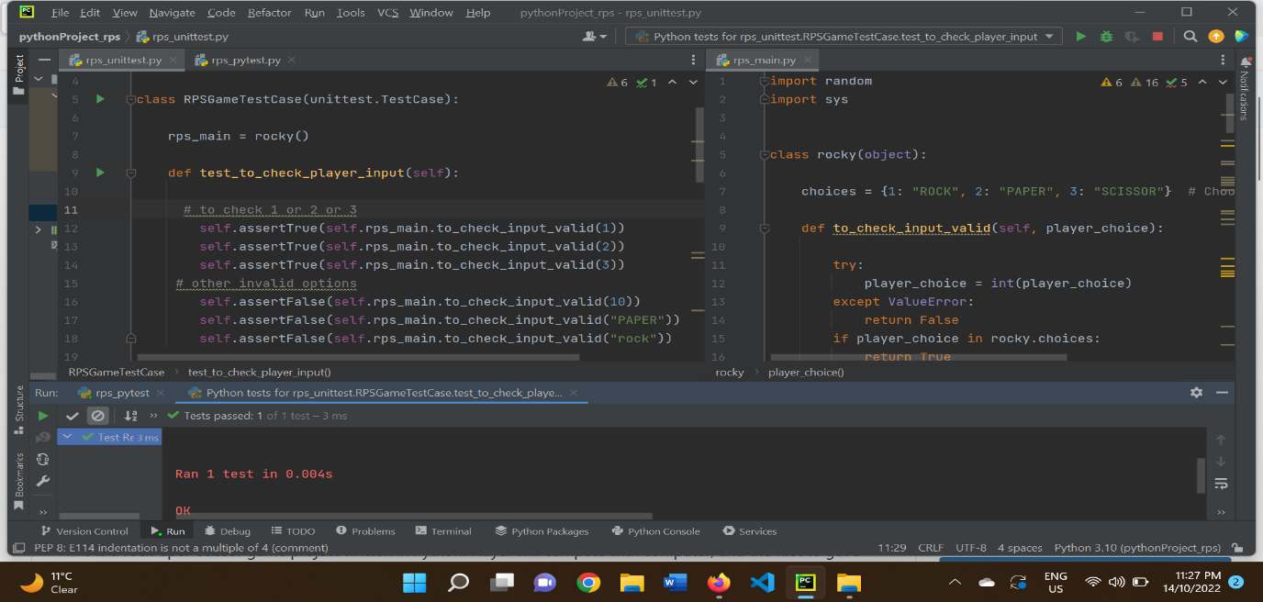

In below image I tried with false options and test was failed.

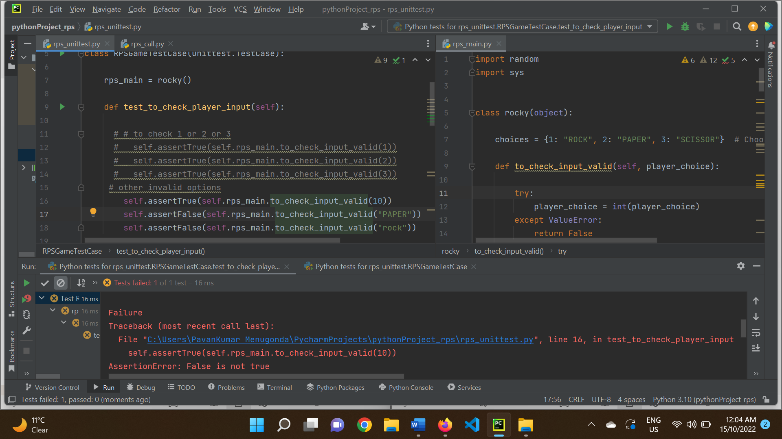

**TEST 2:**

In the second test I am checking if the player has chosen valid input

1. Here I am checking if “Rock” == “Rock”
2. If it is true the test is passed

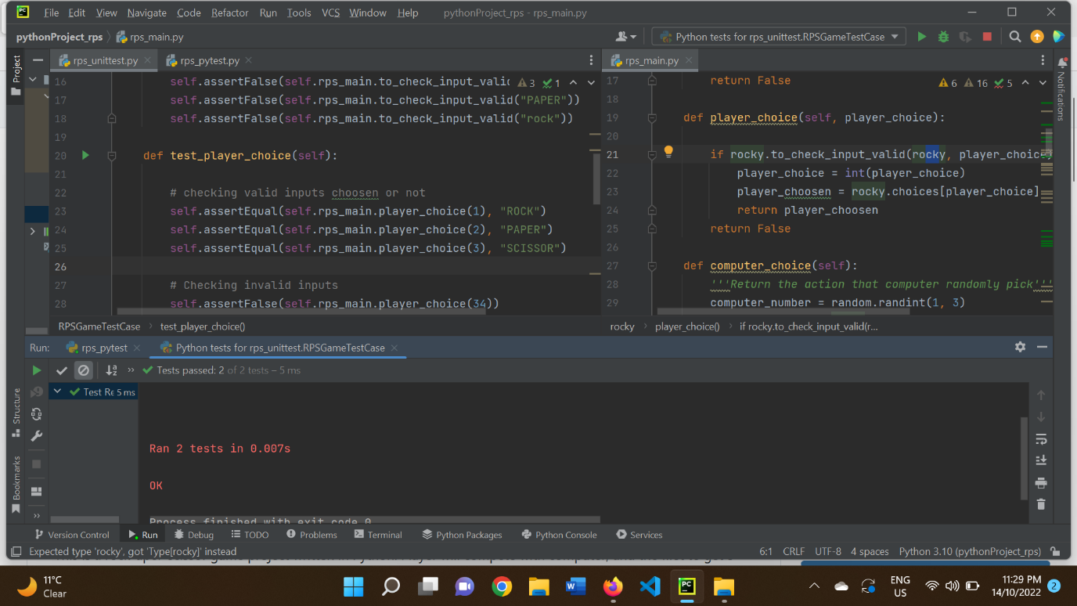

I tried with the false input and the test was failed

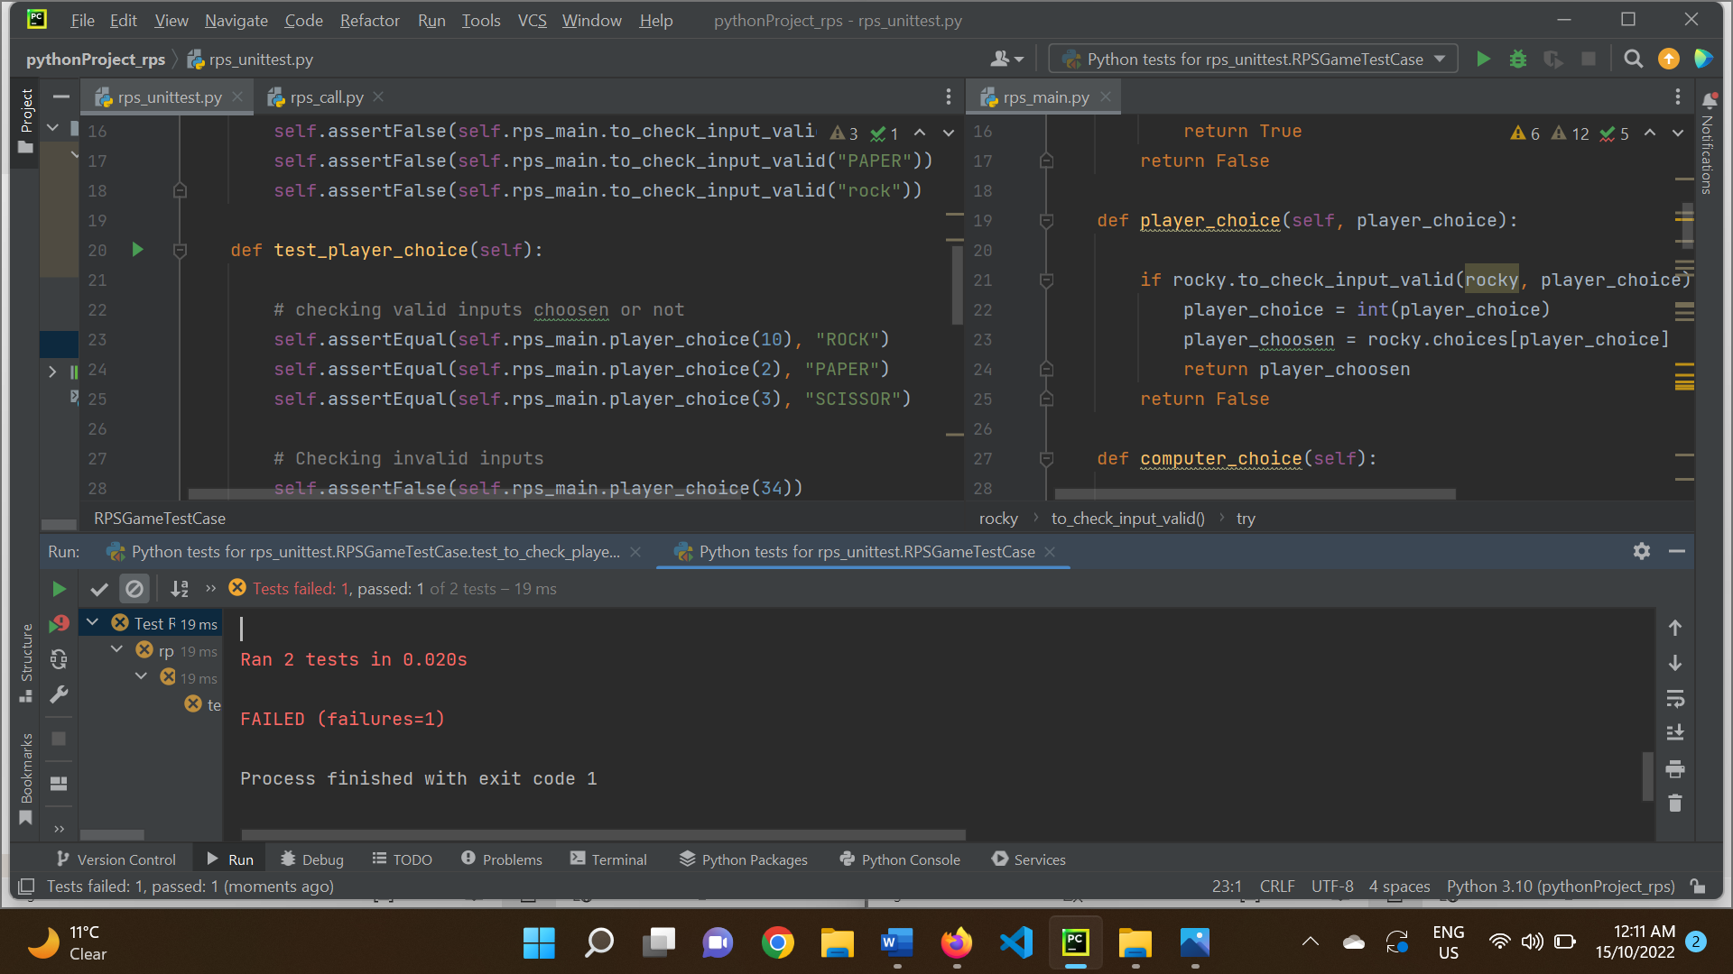

**TEST 3**

In the third test I am checking matched chosen option

1. Here the test is doing if user choice = “rock” and computer choice= “rock”
2. Then it returns true.

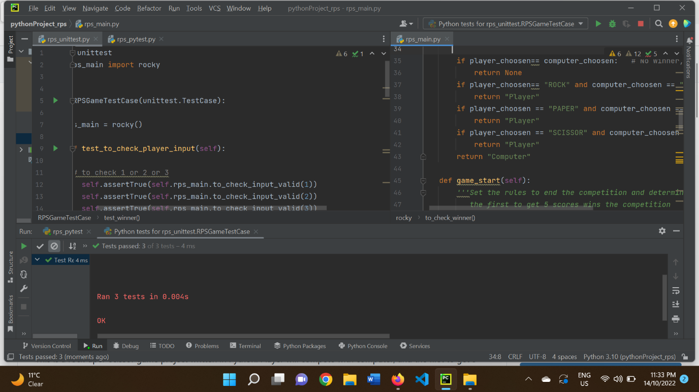

I tried with the false input and the test was failed

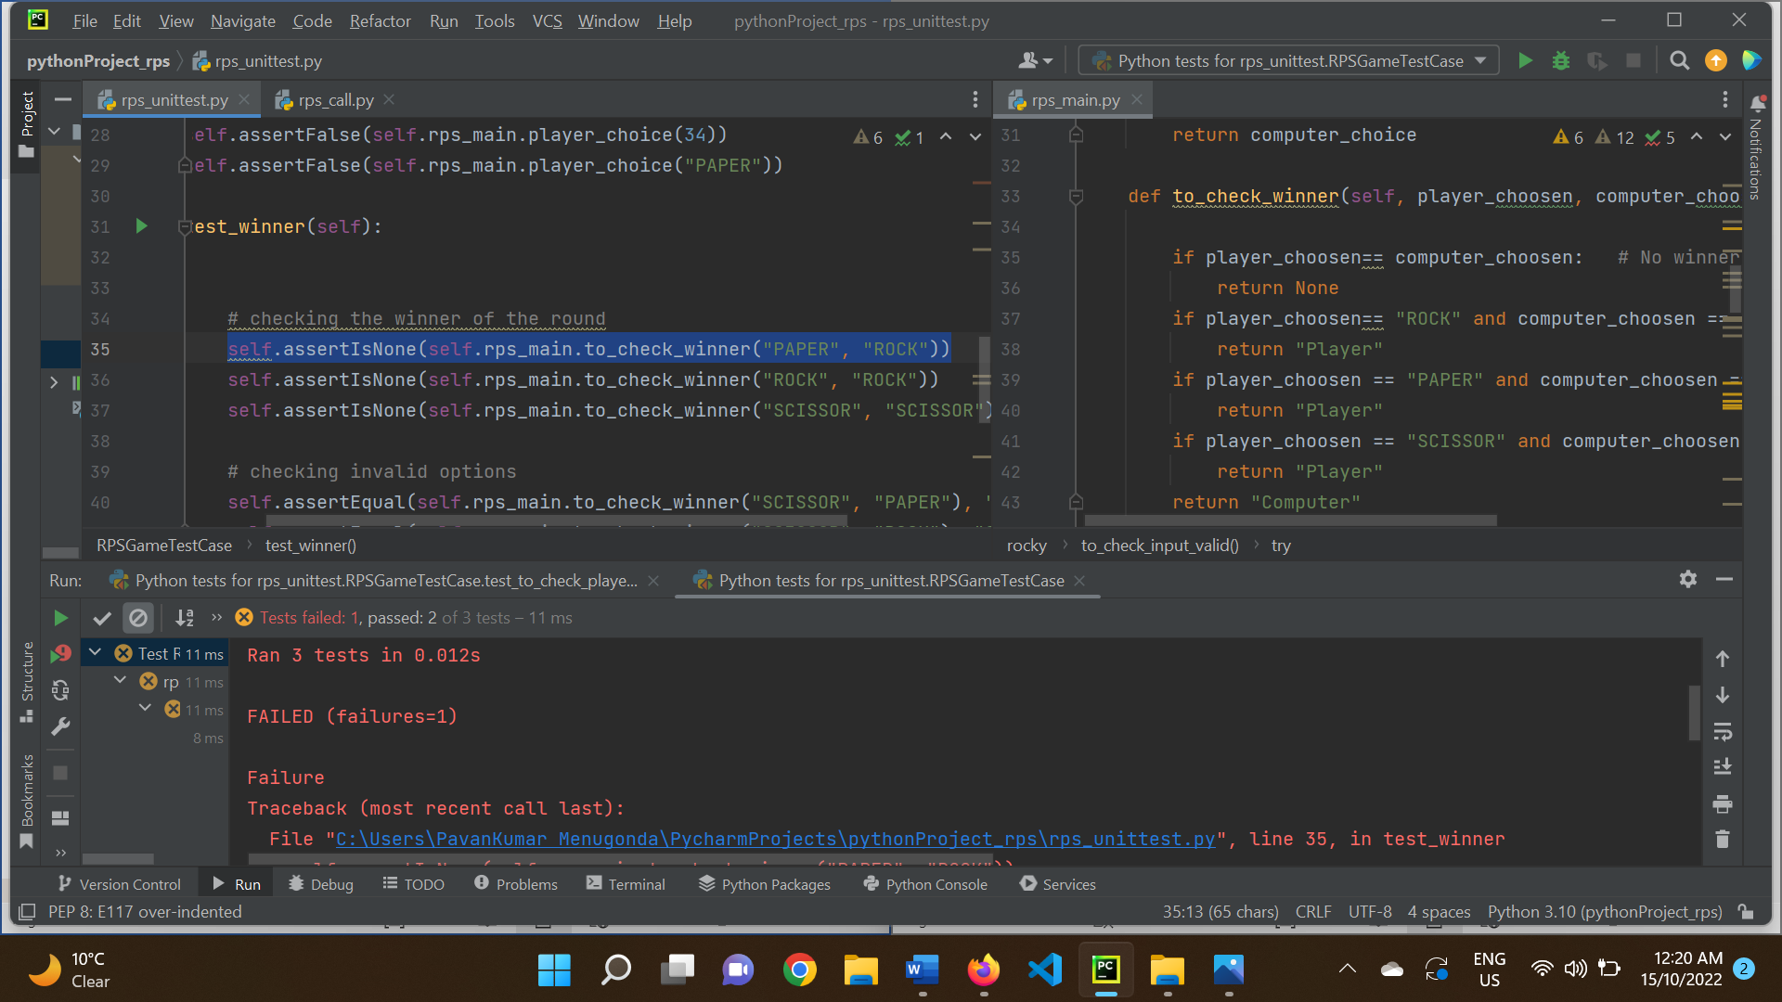

**Output:**

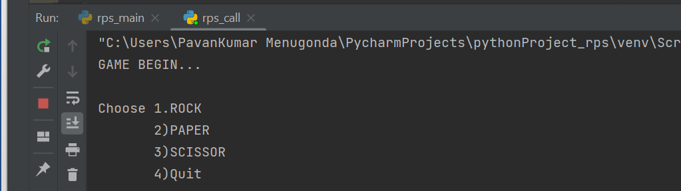

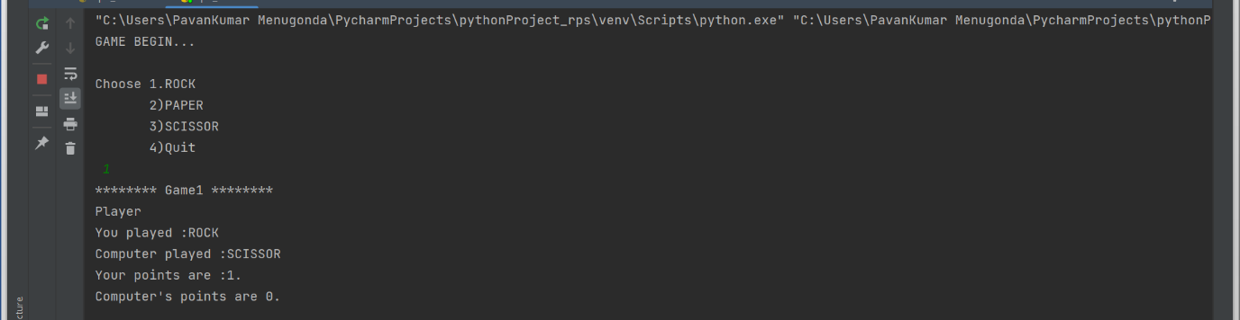



**Conclusion:**

TDD is important such that software development also based on testing. I am using TDD first time in this course, In the project, I check single component of code and expected still runs after making changes. we can save time by testing and debugging the code. Efficient testing on unit needs to be improved. Still there are few flaws in my code I can be improve by practising these techniques and tools regularly and on every small program I write.

**GitHub link:**